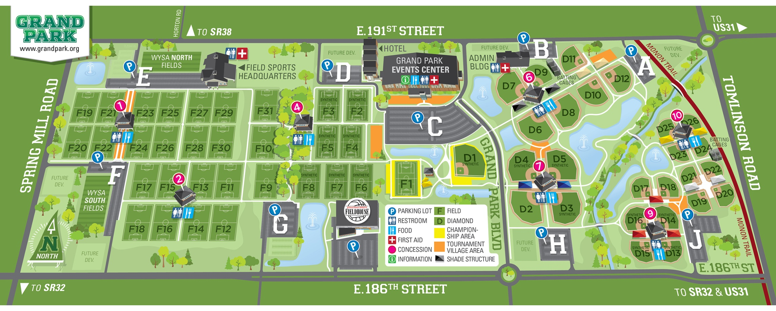
Field 11 and 12 – Park in lot A or B
All other fields – Park in lot J
Overflow parking – lot H
Turf fields are 11, 12, 13, 14, 15, 16 – Only tennis, turf, or molded cleats are allowed.

